DNase treatment

(Turbo DNase kit – ambion)

For each sample, place following in nuclease free, autoclaved 500ul PCR tube.

|  |  |
| --- | --- |
| Component | Volume (µl) |
| DNA contaminated RNA | 10 |
| Nuclease free water | 10 |
| Turbo DNase buffer | 2 |
| Turbo DNase enzyme | 2 |

Follow procedure below:

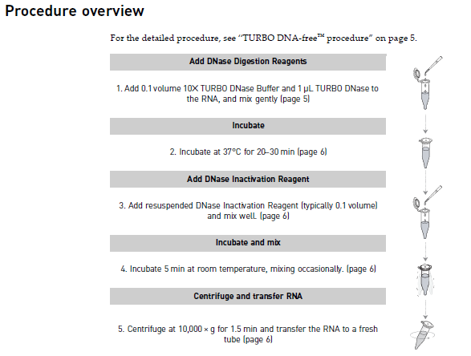

Mix with pipette

Flick tube every ~ 1 minute

2 ul of inactivation reagent

At step 5 take care not to pipette up ANY of the DNase inactivation agent.

Finish with a volume of ~22ul

Put:

* 10ul in a 200ul tube for cDNA production
* 10ul in second 200ul tube -> extra if cDNA production doesn’t work first time
* 2ul to PCR to test DNA free using universal primers (please see next page)

# PCR to test DNA free RNA:

It is essential to dilute template in case of inhibitors which could result in false negative.

For each sample do three dilutions of template:

1 x neat;

1 x 1in2 dilution (0.5µl template + 0.5 µl PCR water)

1 x 1in5 dilution (0.5µl template + 2 µl PCR water)